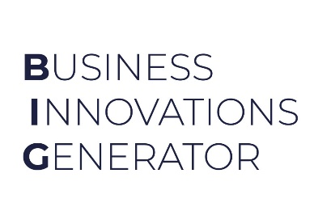

v.1.0
MIlestone setting DOcument
For BIG Incubation Programme

Milestone Setting Guidelines

As a next step, you are required to set 2 milestones for your start-up.
You may use the following guidelines for the start and completion dates when setting the milestones.

Start By: <incubation kick-off date>
- (Estimated incubation kick-off months are March for the January BIG intake, August for the May BIG intake and November for the September BIG intake)

Complete By: (for all milestones) should be within 6 to 8 months from the incubation kick-off date.

Some suggestions & samples are given below for your ready reference.
Please provide a minimum of:
- 1x product or technological development milestone
- 1x business development (BD) milestone
Samples provided here are for you reference, you may please customize it to meet your requirements and suitable for the start-up.

SAMPLES:
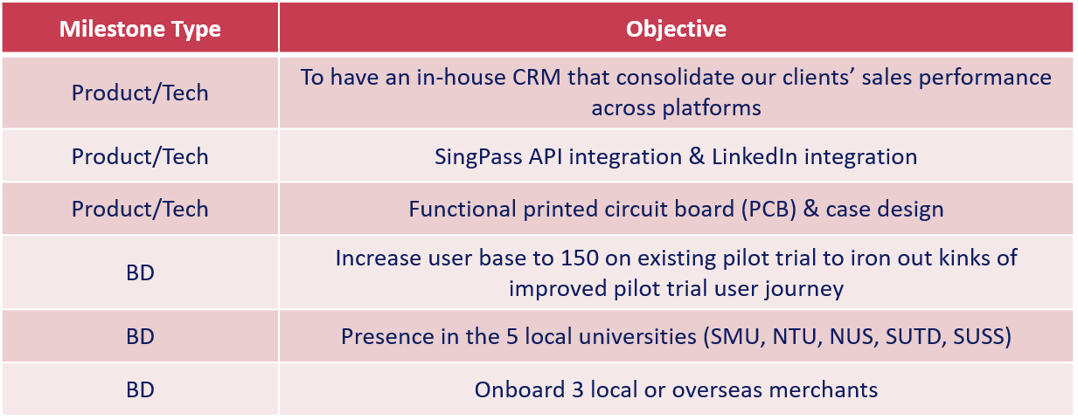
Startup Name | Ambient Systems
Are you a Startup SG Founder Ivan Damnjanovic? | No
Cohort | Jan ‘22

Priority
Priority |  | Objective  (Overarching goal) | Action  (what are the steps that you’re planning to take to achieve this?) | Start by:  (DD/MM/YY) | Complete by:  (DD/MM/YY)
1 | BD | Develop 3 use cases for the product through Proof-of-Concept (POC) Projects | Month 1:  - Prepare list of local accounts (e.g., JTC, NUS, Changi Airport Group, CapitaLand, SMRT)  - Identify relevant contacts and process to connect  - Revise offering slide deck and propose POCs  - Prepare [Team member] video  Month 2:  - Organize meetings and discussions  - Draft POC agreement with prospective customers  Month 3-6:  - Work with stakeholders to implement the platform and model (e.g., connect data feeds via API or set-up localized gateway to aggregate site-level data from sensors, controls, and other sources)  - Document outcomes and prepare case study | 01/03/2022 | 01/09/2022
2 | Product and Tech | Finalize Product Offering | - Adapt current UX / UI designs based on customer conversations  - Refine the machine learning model using a combination of proprietary (collected), open-source, and simulated data  - Look into IMDA accreditation and other standards  - Develop cloud-based web app for users to access the outputs | 01/03/2022 | 30/04/2022
3 | Fundraising | Complete Pre-seed Round Fundraising ($300k USD) | - Finalize fundraising pitch deck  - Send investment deck to personal network  - Arrange calls and discussions  - Organize investment agreements  - Term sheets and investment agreements | 01/03/2022 | 30/04/2022

Prepared & Signed by Startup Founders | Approved by IIE Representative (if applicable): | Approved / Endorsed by EiR:
Name & Signature:  Title:  Date: | Name & Signature:  Date: | Name & Signature:  Date:

